**Security:**

**Everything must be HTTPS**

I’ll start by saying, to do any of this securely, you need EVERY resource you are working with to be using the HTTPS protocol (latest TLS version). If anything is not HTTPS, you could be passing important information in the clear.

Row Level Security is User-Based Automatic Data Filtering. When a user views a Workbook or Data Source in Tableau Desktop or Server, they only see the **rows** of data they are **entitled** to. This is separate from Permissions, which handle if someone can view / interact / etc. with the Workbook or Data Source.

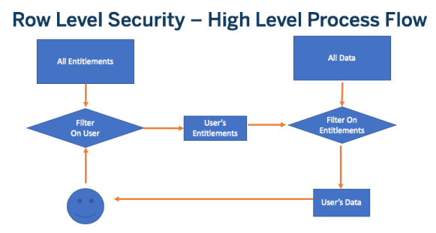

Regardless of how it is implemented, Row Level Security follows this workflow:

1. User is identified
2. The set of Data Entitlements for the User is retrieved from all possible Data Entitlements
3. The Data is filtered by that set of Data Entitlements
4. The filtered data is returned to the end user

Tableau Desktop has a “Create User Filter” option in the Server menu, but it is completely manual and hard-coded. For dynamic row level security that ties into a database or a security service, you’ll need to connect the user information to the data that exists somehow.

Row Level Security for Extract:

Starting in 2018.3

* The design for row level security will be the same in both live connections and extracts
* Extract files with security will create much faster
* Best practices for entitlements tables are now feasible in Extracts

**Security**

Entitlements

User----🡪Authentication------🡪Authorization

Object

Level/Column Level/Field Level Security, Workbook

RLS/User level /Data Level Security

Collection of sites as Tableau Server

Collection of projects as One Site

Collection of Workbooks as Project

If we have multiple scenarios’ like,

User-1 user-2 user-3 user-4

China USA Indonesia INDIA (DB) data Base



Here we have workbooks 10

Scenarios:

1. If all the users have Reports display or Hang
2. All the reports data getting same or not
3. Data Base is in India so data open only in India all other countries have blank data

Here all user are open the reports at a time then reports will be hang not showing anything. Why because if millions of data will be there then all the users open at a time may be server will hang on or not showing anything,

Here we have two options there are:

Horizontal scaling

Vertical scaling

A

A1 A2 A3 A4

This is Horizontal Scaling servers are divided as horizontally if we have large data set then we use horizontal scaling and if we add incremental refresh and full refresh data loads are different ,if server will be up and data loading at that time ,

User 1 opens A then it will show old data and refresh data,

User-2 opens A2 it will show old data only why because loads are not completed